Course Code: CSA1557

Course Name: Cloud Computing and Big Data Analytics

M.Gowripriya

192224223

4) Create a simple cloud software application for Library book reservation system for SIMATS library using any Cloud Service Provider to demonstrate SaaS include the necessary fields such as Title of the book, author, publications, 6 Year, edition, no of copies, Rack no, status (taken/returned) etc

AIM: To Create a simple cloud software application for Library book reservation system for SIMATS library using any Cloud Service Provider to demonstrate SaaS

PROCEDURE:

step1: Go to zoho.com.

step 2: Log into the zoho.com.

step 3: Select one application step.

step4: Enter application name as library book reservation system.

step 5: Created new application as library book reservation system.

step 6: Select one form

step 7: The software has been created.

IMPLEMENTATION:

STEP1: GOTO ZOHO.COM

STEP 2: LOGIN TO THE ZOHO.COM

STEP 3: SELECT ONE APPLICATION

STEP 4: ENTER APPLICATION NAME

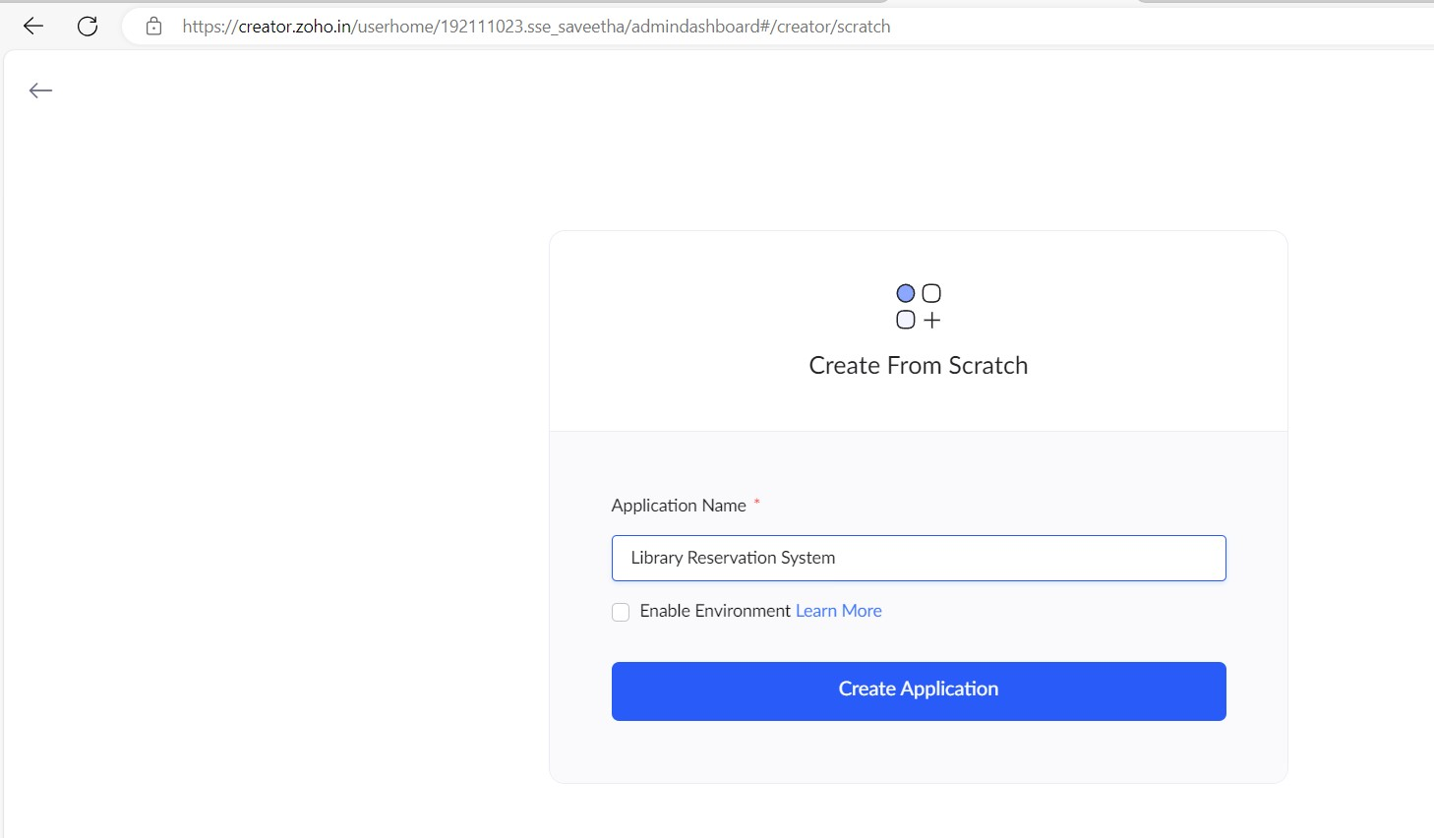

STEP 5: CREATED NEW APPLICATION

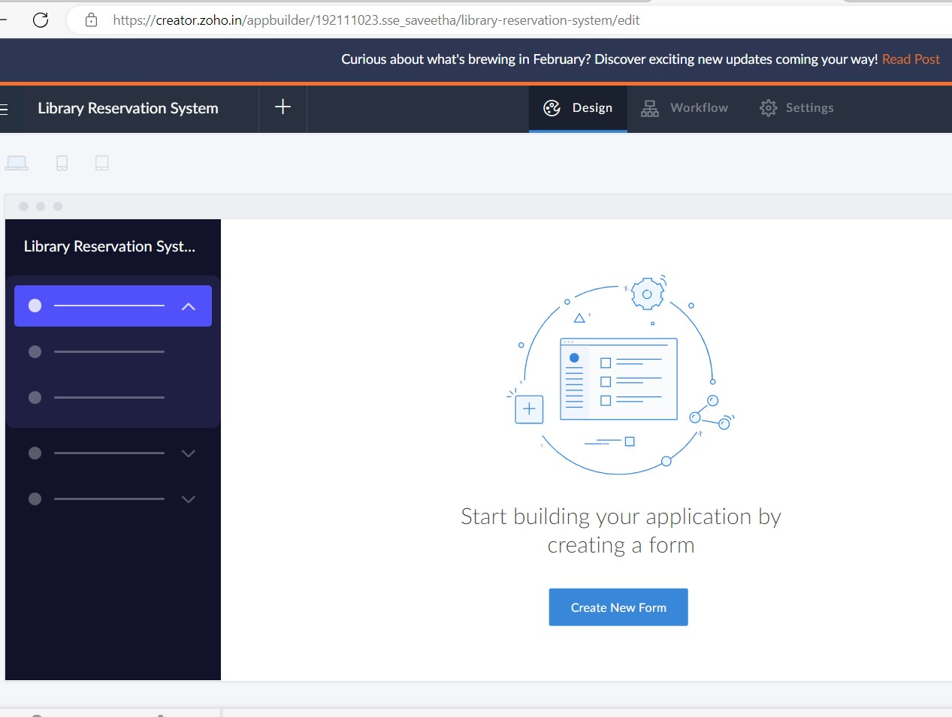

STEP 6: Select from Stratch and Create form as Book.

STEP 7: The form has been created as Book

Choose the fields.

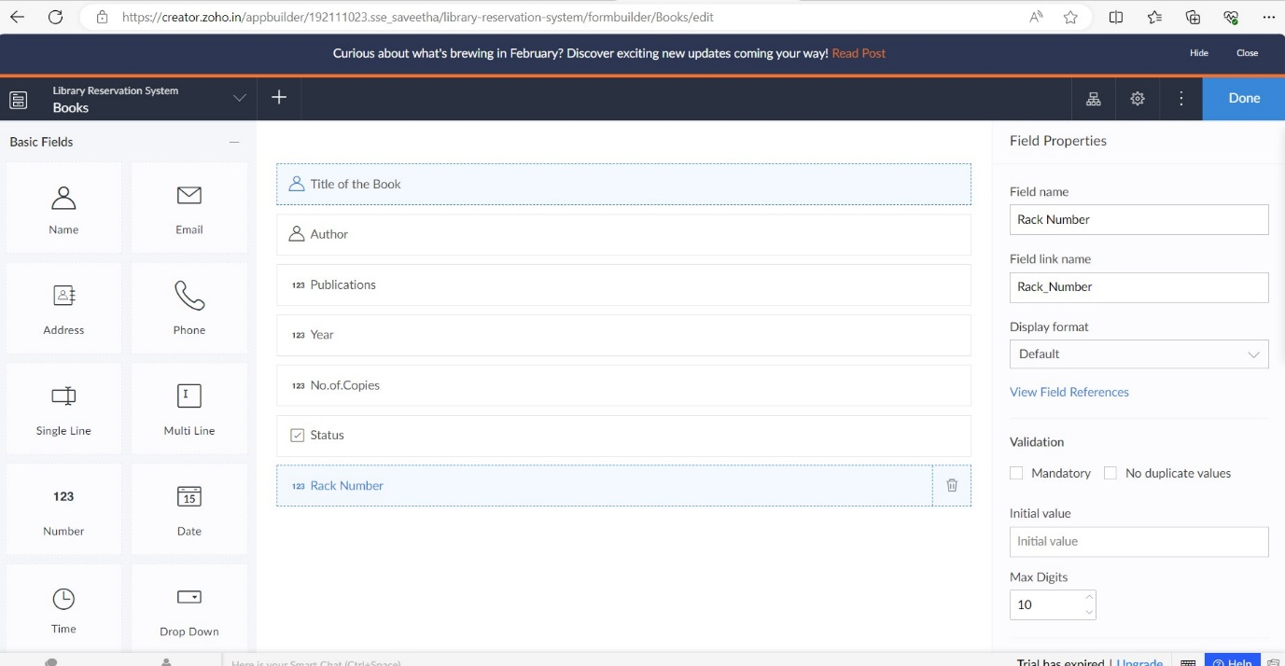

STEP 8: Click Access Development Live

STEP 9: Enter the details of the Book.

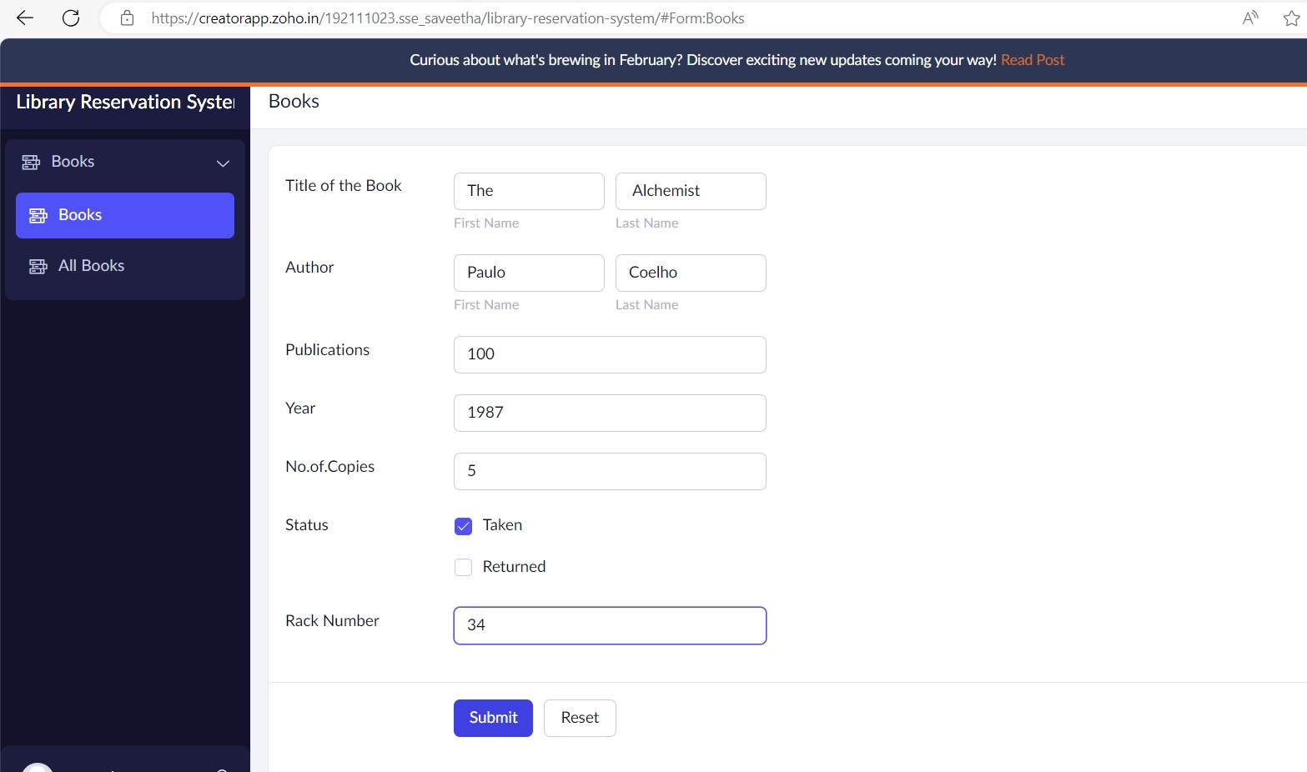

STEP 10: The report has been registered in the Book report.

